CAS PY 106

Prelecture Note 27

1. Polarized Light
2. In linearly (or plane polarized) light, the electric field vectors all lie in one plane
3. 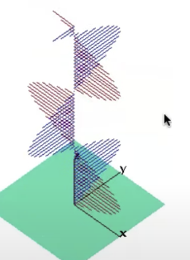
4. So do the magnetic field vectors, because they’re perpendicular to the electric field vectors
5. Most light sources emit unpolarized light, but there are several ways light can be polarized, including reflection, selective absorption, and scattering
6. Polarizers: polarization by selective absorption
7. Dichroic materials polarize light by selectively absorbing light with electric field vectors pointing in a particular direction
8. If the material is thick enough, the light emerging from the material will be linearly polarized
9. Polarizers (such as the lenses of polarizing sunglasses) are made from this kind of material
10. If unpolarized light passes through a polarizer, the intensity of the transmitted light is ½ of what it was coming in
11. Malus’ Law
12. If linearly polarized light passes through a polarizer, the intensity of the light transmitted is given by Malus’ law:

I1=I0\*cos2(delta Theta)

Where delta Theta is the angle between the polarization direction of the light and the transmission axis of the polarizer

1. When light passes through a polarizer, it comes out polarized along the direction of the polarizer’s transmission axis
2. Crossed polarizers – two polarizers, in sequence, with their transmission axes perpendicular to one another – block all the light
3. 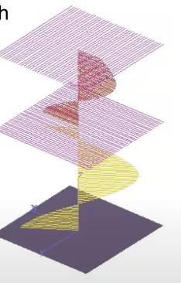
4. Polaizer example, continued
5. 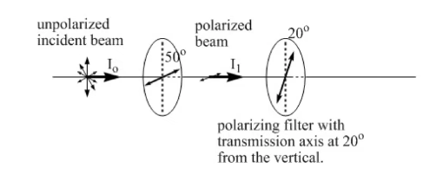
6. Starting with unpolarized light, passing through the first polarizer, the intensity is reduced by 50%, and the beam is now polarized (aligned with the polarizer’s transmission axis)
7. Then, you would apply Malus’ law to see how much light passed through the second polarizer
8. If the incident beam is linearly polarized, Malus’s law tells us how much light gets through the first polarizer
9. Again, the beam comes out polarized, aligned with the polarizer’s transmission axis
10. Then, you would apply Malus’ law to see how much light passed through the second polarizer
11. Polarization by scattering
12. Scattering in the atmosphere occurs when light is absorbed by an atom or molecule, and then emitted again, usually in a different direction
13. Light scattering off atoms and molecules in the atmosphere is
14. Unpolarized if the light keeps traveling in the same direction;
15. Linearly polarized if it scatters in a direction perpendicular to the way it was traveling
16. Somewhere in between if it scatters at another angle
17. Polarized sunglasses are designed to block light that reflects off horizontal surfaces
18. The process of reflection can at least partly polarize the light horizontally, so polarized sunglasses block horizontally polarized light